~ GEOMETRY KITE PROJECT ~  3. . . 2. . . . 1. . . Lift-off! Here we go! Hold on tight. You are about to take a flight with your very own kite designed and built by none other than YOU!  Over the next several of days, you and a partner will not only build a kite, but also research kite history, find kite plans, build that kite, decorate your kite, and of course TEST your kite outside! A short paper is also involved in this project. This won't be easy, but fun is guaranteed! Remember your geometry skills while building your kite and writing your paper.  To make this project more "green", you are also required to use recycled or natural materials in your kite's construction. Be on the lookout for materials you might like to use! | Useful Websites  History of Kites  Kite Making Plans  How to Make a Kite (plans)  All About Kites  How to Make and Fly Kites  Make Your Own Kite (basic model)  Kite Safety  Why Kites Fly

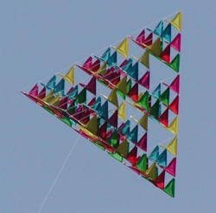

TASK

As a result of this project you will not only be an expert kite builder, but you will have some real world geometry experience. During this project you should keep in mind what we have learned about different geometric shapes, angles, lines, and more.

You and a partner will find and research a particular kite plan and then construct that kite following your plan. You and your partner will also write a short summary, including your kite type, the geometry that is involved in your kite, any problems that you encountered while constructing the kite, and at least one fun fact you found while researching for your kite!

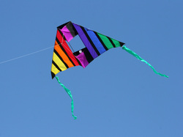

PROCESS

Choose one other person in this class whom you can work well with, and if need be, could get together outside of class time to complete this project.

Here's a couple of helpful hints to remember while searching for the perfect plan:

~ Your kite must have some geometry ideas involved.
~ You are on a limited time schedule
~ You must work together!!!

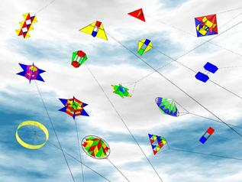

THE FOLLOWING ARE GUIDELINES FOR CHOOSING YOUR KITE

1. Geometry must be involved in the following ways:
~ Your kite should have at least two sets of either congruent figures or similar figures.
~ Your kite should be symmetrical!
~ You should have at least two types of angles used in your kite (with the exception of a box kite).
~ Your kite should have lines that you explain in your summary paper where they are at(parallel lines, intersecting or perpendicular lines)
~ You should be able to calculate the angle measurements and side lengths of your kite. These measurements will be included in your summary paper.

2. You have class time to complete your kite, but you may need to work outside of class during the week or on the weekend.

3. Your ultimate goal is to get your kite to fly!!! That is, incorporate what you know and what you learned about physics from the articles and websites. Be careful with your measurements and construction- you want to be as precise as possible.

FLYING YOUR KITE!!! After everything is done (with the exception of the paper) we will take a day to fly our kites.

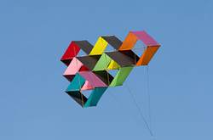

SUMMARY PAPER

You should write a brief paper describing the process of researching, building, and flying your kite. Describe the parts that went well, the problems that you came across, and one fun fact that you learned while researching your kite.

The following is the guideline which your paper must follow:

1. Give details about kite history and what you learned about kites while researching them. (5 points)

2. Describe the building process of your kite. What materials did you use? Make a detailed list of all materials used. Tell how you constructed angles, lines, shapes, etc. Explain the different types of lines that are included in your kite, and the different types of angles. (5 points)

3. Create a diagram of your kite and organized table to show all your measurements. Give the side lengths and angle measurements of your kite and indicate what each measurement corresponds with on the diagram. Make sure you name your kite. (5 points)

4. Give a short explanation on kite safety. (5 points)

5. Explain your research methods. That is, in detail, tell about your method of finding and choosing the kite you chose. Also, include why you choose your kite. (5 points)

6. Tell about your kite flying experience. Did it fly? Why or why not? What could of you have done differently? (5 points)

7. Finally, tell me about this project. What did you like, not like? What would you change? What was your favorite part? Your least favorite part? Tell me anything you would like to pertaining to this project. (5 points)

8. Make a list web sites or other sources you used. (5 points)

9. Your kite (10 points)

All of the above must be included in your paper; however, you may mix the order up.

The paper should be typed or very neatly handwritten. The length of the paper is up to you - just make sure all information is clearly included!

