Problem Based Math

Transcontinental Railroad offers insights into topics in American history including the settling of the West.

Research trains and their history
Introduction:
Transcontinental Railroad
- General Article:
Workers of the Central Pacific Railroad
- General Article:
Workers of the Union Pacific Railroad
- General Article:
Asa Whitney (1791-1874) and Early Plans for a Transcontinental Railroad
- General Article:
Native Americans and the Transcontinental Railroad
- General Article:
The Race to Utah
- General Article:
Tunneling in the Sierra Nevada
- General Article:
The Chinese Workers' Strike
- General Article:
Nitroglycerin
- General Article:
The Impact of the Transcontinental Railroad

- Workers of the Union Pacific Railroad

1.Create a timeline of when trains created and why they were utilized..
Timeline:
Transcontinental Railroad

2.Draw or trace a map of the United States and label the following items:
(a) the Union Pacific and Central Pacific railroads,
(b) the Oregon Trail and at least one other significant route taken by wagon trains,
(c) the Great Plains,
(d) areas occupied by at least two different Native American tribal groups mentioned in the film,
(e) the cities at which the Transcontinental Railroad started and ended
(f) deposits of coal, gold, and silver.

3. Find the most direct and economical way of traveling from New York City to Los Angeles using a train.
Economics
4. Read about workers of the Central Pacific, Union Pacific workers, and the Chinese workers' strike. Using information from these readings, write three letters from railroad workers to their families: one from a Chinese worker, one from an Irish worker, and one from a white foreman. In your letters, show the different perspectives and experiences of the three groups.

5. Create a diagram, flow chart, or three-dimensional model, some mechanical or engineering aspect of the transcontinental railroad that interests you. For example, you might show how a steam-powered locomotive moved (or stopped), how steel rails for the railroad were manufactured, how railroad tunnels were carved through solid mountains, or how railroad bridges were constructed.

Introduction: Transcontinental Railroad
Other Introductions
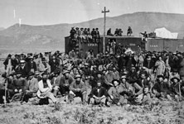
The Andrew j. Russell Collection
Hundreds gathered to witness the completion of the railroad
On May 10, 1869, at Promontory Summit, Utah, a boisterous crowd gathered to witness the completion of one of the greatest engineering feats of the 19th century: the building of the transcontinental railroad. The electrifying moment marked the culmination of six years of grueling work. A telegrapher sent a simple, yet thrilling, message to the waiting nation: "DONE!"
Peopled by the ingenious entrepreneurs whose unscrupulous financing got the line laid, the brilliant engineers who charted the railroad's course, the armies of workers who labored relentlessly on the enterprise, and the Native Americans whose lives were destroyed in its wake, The Transcontinental Railroad is a remarkable story of greed, innovation and gritty determination.
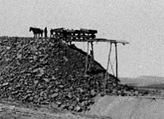
American Heritage Center, University of Wyoming
Construction on the railroad
As always, dreamers were ahead of the curve; and as always, their enthusiasm tended to get ahead of practical considerations. "It is in our power," wrote Samuel Dexter, editor of the Western Emigrant in 1832, "to open an immense interior country to market, to unite our eastern and western shores firmly together." It wasn't, as it turned out, in America's power for almost forty years.
The visionary who finally got the project underway was a practical man, a West Coast-based designer and builder of railways, Theodore Judah. In the summer of 1860 he picked a route through the wilderness of California's Sierra Nevadas and began looking for investors. A few years later the Central Pacific Railroad with four major private investors and some funding from Congress began the awesome task of laying track through the mountains. In bitter cold and blazing heat, workers built scores of bridges and trestles and drilled thousands of feet of tunnel while advancing 690 miles across some of the roughest terrain in America. Crucial to their success were the efforts of Chinese laborers who risked their lives to blast their way through granite cliffs.
Advancing from the east was the Union Pacific which built westward across plains and deserts, braving blizzards and raids by displaced Native Americans to complete the 1,086-mile journey from Omaha, Nebraska. As the tracks moved deeper into the wilderness, boomtowns sprung up to cater to the workers' appetite for whiskey, women and wagering. Hastily built, these settlements, known as "Hells on Wheels," flourished for a few weeks, then were deserted as the railroad moved on.
When it was completed, the railroad transformed America. It unleashed a tidal wave of growth as immigrants moved west. Thousands of towns materialized in the corridor created by the railway. Transcontinental trains fostered a new agricultural empire by bringing farming machinery to the West, and carrying crops and livestock to the coasts. And the line gave birth to other lines -- three additional transcontinental railroads in 20 years. The railroad also profoundly affected the national psychology, creating a new spirit of optimism and unity. Just as the Confederate surrender at Appomattox Courthouse affirmed the union of North and South, so the Golden Spike established an unbreakable link between East and West, a strong band of iron that bound America together, making it really and truly "one nation, indivisible."

Timeline: Transcontinental Railroad
Other Timelines
1769
Scottish mechanical engineer James Watt patents his design for the first practical steam engine, paving the way for the mechanized production of the Industrial Revolution.

1825
In England, George Stephenson engineers the world's first railway locomotive. Based on Stephenson's years of experimentation with steam-driven vehicles (the first of which he built in 1814), the Locomotion pulls coal on a nine-mile track.

1830
Peter Cooper finishes America's first steam locomotive. The Tom Thumb carries passengers and goods along 13 miles of track between Baltimore and Ellicott's Mills, Maryland. By year's end, similar locomotive routes exist in New York and South Carolina.

1841
The first settlers move westward across the Northern Great Plains on what will come to be known as the Oregon Trail, soon a conduit for emigration.

1845
Asa Whitney presents a resolution in Congress endorsing the funding of a railroad to the Pacific. Despite six years of campaigning, the issue dies as increased sectionalism and self-interest distract the legislature. The railroad remains a potent symbol in the public consciousness.

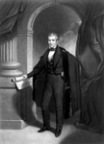
Library of Congress

President James Polk

December 1848
Outgoing president James K. Polk stirs a new fervor for westward expansion by announcing the discovery of gold in Oregon Territory.

September 9, 1850
Gold-rich California becomes the 30th state admitted into the Union.

June 1859
Discovery of the massive Comstock Lode lures miners to Virginia City, Nevada, in search of gold and silver ore. The news revitalizes the California mining economy, and urges exploration of a road east across the Sierra Nevada.

July 1860
Engineer and enthusiast Theodore Judah solves the great riddle of the Pacific Railroad when he reaches Donner Pass (named for the ill-fated emigrants of 1846). Judah immediately recognizes the location as ideal for constructing a line through the Sierra Nevada.

November 1860
Judah meets Sacramento merchant Collis P. Huntington, who agrees to invest in his railroad project. Huntington brings in four other investors: Mark Hopkins, James Bailey, Charles Crocker, and Leland Stanford. The six men organize themselves as the first Board of Directors of the Central Pacific Railroad Company.

October 1861
Having completed his survey of the Sierra Nevada, Judah returns to Washington armed with maps and profiles to lobby for appropriations for the Central Pacific Railroad Company.

July 1, 1862
Congress passes and Lincoln signs the Pacific Railroad Bill. The document endorses Central Pacific efforts to build the California line while simultaneously chartering a Union Pacific Railroad Company to build west from the Missouri River. The bill grants each enterprise 6,400 acres of land and $48,000 in government bonds per mile built. It does not designate a meeting point for the lines.

January 8, 1863
Newly elected California governor Leland Stanford shovels the first load of dirt at the Central Pacific groundbreaking ceremony in Sacramento.

Summer 1863
Tensions build among the Central Pacific board around financial and contractual issues. Judah sails east to look for new investors.

October 26, 1863
The Central Pacific spikes its first rails to ties.

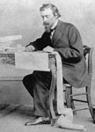
The University of Iowa Libraries

Thomas Durant
October 30, 1863
Thomas C. Durant, who has illegally manipulated a controlling interest in the Union Pacific Railroad Company, gets himself appointed the railroad's vice president and general manager.

November 2, 1863
Taken ill on his journey, Theodore Judah dies in New York City.

December 2, 1863
In a gala ceremony, the Union Pacific breaks ground in Omaha, Nebraska, although it is some time before the railroad will go anywhere.

July 1, 1864
As lobbyists -- among them Durant, who hands out upwards of $400,000 -- distribute cash and bonds among legislators, Congress passes a revised Pacific Railroad Bill. It doubles the land grant, cedes all natural resources on the line to the railroads, and removes limitations on individual stock ownership.

October 1864
Union Pacific crony Herbert M. Hoxie wins the Union Pacific construction bid, then signs the contract over to Durant's new company, Credit Mobilier. The move allows Durant to pay himself for construction, generating giant profits without congressional oversight.

November 29, 1864
The Sand Creek Massacre. Cavalrymen led by Colonel John Chivington slaughter 150 unarmed Cheyenne and Arapaho Indians, most of whom are women and children.

January 7, 1865
Cheyenne, Arapaho, and Sioux raiders ravage the would-be railroad town of Julesburg, Colorado, in retaliation for Sand Creek. They destroy telegraph wire in Platte Valley, then return and raze Julesburg to the ground.

January 20, 1865
President Abraham Lincoln asks Massachusetts senator Oakes Ames to help manage the Union Pacific Railroad. Oakes Ames soon invests in Credit Mobilier and promotes its interests in Washington, D.C.
Around the same time, contractor Charles Crocker convinces Central Pacific foreman James Harvey Strobridge to try Chinese workers as a means of expanding their labor force, which at this time numbers just a few hundred Irishmen.

April 9, 1865
Robert E. Lee surrenders to Ulysses S. Grant. The Civil War ends. Masses of soldiers demobilize, many of whom will soon move west. The Union Pacific has yet to spike a rail.
Five days later, on April 14, President Lincoln is assassinated. His body will be carried back to Illinois by rail, on a special Pullman car.

July 10, 1865
With Durant's activities facing increased scrutiny in D.C., the first rails of the Union Pacific line are spiked in Omaha.

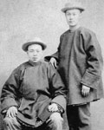
California State Library

Two Chinese workers
Late Summer 1865
Central Pacific crews begin the slow job of hand-drilling 12 tunnels through the Sierra Nevada, averaging a few inches through the rock a day. By year's end approximately 6,000 Chinese men will work in and around the tunnels. They will constitute up to 80% of the workforce throughout the project.

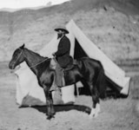
The Andrew J. Russell Collection, The Oakland Museum of California

Jack Casement
February 1866
Realizing the importance of increasing production, Durant hires General Jack Casement as the Union Pacific's construction boss. Casement spends the winter at Omaha, preparing the rolling dormitories his crews will use in the coming year.

April 16, 1866
A nitroglycerin explosion destroys the Wells Fargo Office in downtown San Francisco.

May 1866
Durant hires General Grenville Dodge to be chief engineer of the Union Pacific.

July 1866
Casement crews add 60 miles of track to bring the Union Pacific line to the 100 mile mark.

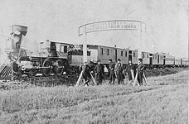
National Archives

Passing the 100th meridian line
October 6, 1866
Casement and his crews pass the 100th Meridian line on the prairies of Nebraska, guaranteeing the Union Pacific the irrevocable right to continue westward, as stipulated in the Pacific Railroad Act. Durant throws a grand "100th Meridian Excursion" for dignified guests, featuring a mock Pawnee ambush.

November 1866
North Platte, Nebraska sits at the end of the Union Pacific line, and soon features a potent combination of saloons, prostitutes, and criminals. This assemblage and the others like it that follow the westward press of empire are named "Hell on Wheels" towns.

December 21, 1866
Upset by increased military presence in the Powder River Valley, the most sacred and fertile hunting ground remaining in their possession, a group of Sioux warriors draws cocky Captain William J. Fetterman and his troops into a deadly ambush on the Bozeman trail.

Winter 1867
British chemist James Howden begins manufacturing nitroglycerin on-site in the mountains for the Central Pacific, eliminating the dangers of transporting the compound.

May 1867
Led by the Ames brothers, officers of the Credit Mobilier remove Durant from the Union Pacific presidency. Thus begins a flurry of legal action initiated by Durant against both Credit Mobilier and the Union Pacific, even though he continues to exert nominal leadership over both companies.

June 25, 1867
Summit work in the Sierras grinds to a halt as Chinese workers strike for better wages and shorter hours. Crocker and Strobridge cut off food, supplies, and communication to the Chinese camps. One week later, the men will go back to work at the same wage.

July 4, 1867
Dodge founds the town of Cheyenne in Wyoming Territory. Intended as a transfer point on the Union Pacific line, it will contain the company roundhouse and a military station. The company divides and sells lots to encourage emigrant settlement. By year's end, the settlement's population will exceed 4,000.

August 27, 1867
A group of Cheyenne warriors bends rails and pulls up track at Plum Creek, Nebraska. The resulting destruction derails a work train, which the Cheyenne party loots and burns after killing its crew. The only survivor escapes with scalp in hand.

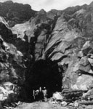
The Denver Public Library

The summit tunnel
August 28, 1867
Central Pacific workers blast through the rock of the Summit Tunnel, completing the most arduous of their tasks in the mountains.

November 30, 1867
As the Chinese lay track, Central Pacific directors lead a ceremonial train excursion to the eastern side of the Sierra Nevada.

December 12, 1867
Despite continued infighting among its directors, Credit Mobilier declares a substantial stock dividend. Oakes Ames becomes popular among legislators eager to get in on the profits. Ames distributes 190 shares of stock in Washington, 163 of which go to 11 members of Congress.

April 16, 1868
Union Pacific construction surmounts the highest point on both lines: Sherman Summit, at an elevation of 8,200 feet in the Rockies. The race for completion -- and territorial holdings -- is on.

May 9, 1868
The Central Pacific sells its first lots in Reno, Nevada.

June 18, 1868
The first passenger train rumbles across the Sierras into Reno.

August 1868
Mormon leader Brigham Young provides Stanford with Mormon laborers for Central Pacific grading work through the Utah desert.

October 29, 1868
The fed-up citizens of Laramie, Wyoming form a Vigilance Committee to combat the town's lawless element. Following a feverish gun battle, the vigilantes succeed in forcing gamblers and outlaws from their settlement, hanging those who remain from telegraph poles and log cabin rafters.

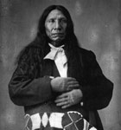
The Denver Public Library

Red Cloud
November 6, 1868
After months of skirmishes known as "Red Cloud's War," the government suggests a treaty, but Native American leader Red Cloud will not condescend to meet until the military have removed themselves from the Bozeman Trail. They agree, and Red Cloud signs the Powder River Treaty, which guarantees the Sioux their massive hunting ground in perpetuity. Red Cloud is thus considered the only native leader to have won a war with the United States.

January 1869
Corinne, Utah is founded. It is the first non-Mormon settlement in the Territory; it will prove to be the last true Hell on Wheels town.

April 8, 1869
After months of increased tension, closed-door Washington lobbying, Congressional pressure, and aborted meetings between the two companies, Dodge and Huntington settle upon a meeting place for their two lines. It takes two days' worth of tempestuous argument, but the men negotiate convergence at Promontory Summit, Utah.

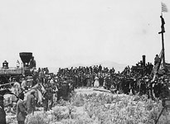
National Archives

Victory Day
April 28, 1869
Victory Day. Charles Crocker decides he has one last thing to show the Union Pacific and the world. In a remarkable feat of strength and organization, his Central Pacific crews lay an unheard-of 10 miles of rail between sunrise and sunset.

May 6, 1869
As Pullman cars move westward toward Promontory Summit, unpaid tie workers block the line and a bridge washes out at Devil's Gate. These developments delay the arrival of Durant and Union Pacific dignitaries by two days.
Despite the delay, jubilees proceed as planned in cities throughout California on May 8. At the Central Pacific ceremony in Sacramento, toasts are raised to the pioneering visions of Asa Whitney and Theodore Judah.

May 10, 1869
Amidst a crowd of dignitaries and workers, with the engines No. 119 and Jupiter practically touching noses, the Central Pacific and Union Pacific railroads join together. Telegraph operators transmitting to both coasts transmit the blows of the hammer as they fall on a golden spike. The nation listens as west and east come together in undivided union.

September 4, 1872
During a heated presidential campaign, the Credit Mobilier scandal erupts in the press, smearing the name of many established government figures who purportedly sold their influence for Credit Mobilier stock. Among them is Speaker of the House James G. Blaine of Maine, who suggests an investigating committee will find the allegations worthless.

February 1873
A Congressional committee investigates the Credit Mobilier. The scandal creates public disillusionment with elected leaders, but the committee hands out very little punishment. All major players escape unscathed, save scapegoat Oakes Ames, who is voted out of Congress and leaves Washington in shame. He will die just months later.

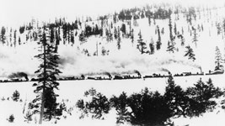
California State Railroad Museum

Train tracks spanned the country
1880
By this time, the Pacific railroad carries $50 million worth of freight annually. It has served as artery for 200 million acres of settlement between the Mississippi and the Pacific. The Plains Indians have been scattered to reservations, and little over 1,000 buffalo remain of the millions that once populated the grasslands. A trip between San Francisco and New York, which once might have occupied six grueling months, now takes a few days.

1882
Ignoring the crucial role Chinese immigrants played in constructing the California infrastructure, Congress passes the Chinese Exclusion Act, banning further immigration of Chinese laborers into the United States for a period of 10 years. Congress will extend this Act in 1892, and again indefinitely in 1904.

1884
Bursting with the profit of the railroad enterprise and bereft over the death of their teenage son, Leland and Jane Stanford endow the Leland Stanford Junior University on family land in Palo Alto, California.

1889
An agreement with the U.S. government divides up Sioux territory in the Powder River Valley, once promised to Native Americans in perpetuity by the Treaty of 1868. The Sioux disperse to six smaller disconnected reservations, and the last great holding of an indigenous people is thrown open to white settlement.

General Article: Workers of the Union Pacific Railroad
Other General Articles

The Andrew J. Russell Collection, The Oakland Museum of California
In the West
Construction got a slow start in Omaha, Nebraska, eastern terminus of the Union Pacific Railroad. By April 1864 the jubilance of groundbreaking had long ago faded into the ether. Chief engineer Peter Dey continued to suffer setbacks in putting together his stalled project. Chief among these was a dearth of labor. Neither Dey nor the firms he wanted to reward with construction contracts could find enough men for the massive job. "It is impossible to do anything in the way of letting this work now without some provision for furnishing men," the engineer wrote to railroad executive Thomas Durant, adding that some provision must be made toward importing an army of men. Durant in turn asked the War Department to ship Dey some portion of those slaves freed by the ongoing Civil War. The government declined. Union General Grenville Dodge offered use of Indian prisoners from his winter campaign. But no practical solutions were forthcoming. By the end of 1865, only 40 miles of track had been laid across the inviting valley.
Veterans for the Railroad's Ranks
The end of the Civil War brought a change of fortune for the Union Pacific. Thousands of demobilized soldiers were eager for work. Additionally, by 1866 the railroad had managed to import Irishmen from the teeming cities of the eastern seaboard. Suddenly swarms of men surrounded Dodge, who had replaced the frustrated Dey as chief engineer. Joining him that winter in Omaha was construction boss Jack Casement.
Military Precision
Working in tandem with his brother, Dan, former Brigadier General Jack ran his men with a military precision that hinged upon the efficient division of labor. Teamsters piloted small horse-drawn carts along freshly-laid track. Men on either side of those carts unloaded rails and moved forward to place them parallel to one another on embedded ties. Gaugers stepped in to ensure the rails were the correct distance apart. Bolters knelt down to join the contiguous rails on either side of the track. Spike men followed behind, dropping spikes onto the grade. Hammer-wielders picked up the spikes, tapped them gently into the ties, then with three heavy strokes of the sledgehammer drove them home, securing the rail to its bed. Teamsters drove their carts forward along the new track, and the whole process repeated itself again and again, an assembly line moving forward on the product it assembled. Behind the workers followed flat cars loaded with supplies, and behind those the portable bunkhouses in which workers resided. On average Casement's men finished nigh on two miles a day. On occasion General Jack was known to complete mind-boggling stretches of much greater length.
Working on the Railroad
Pay varied according to responsibility. Teamsters and graders received the least, while the iron men got the healthiest sum of anybody save their foremen. Like their Irish counterparts on the Central Pacific, the Union Pacific men had a staple diet of beef, bread, and black coffee. Water-borne illness was often a serious concern. Personal hygiene was all but unheard of. The men slept together on bunks in the rolling fortresses Casement had designed for them the previous winter. They were tight quarters in which conditions could be squalid. "To tell the truth, we were troubled by 'cooties,'" remembered one veteran of the crews. Also troubling were fears of the Native Americans across whose land the laborers built their road. There were Native American snipers, raids, livestock rustlings, scalpings, and burnings all along the railroad right of way. Indian sightings sufficed to spook men, and line surveyors did not always return from their routes. News of the slaughter of troops at Fort Philip Kearny on December 21, 1866, "the Fetterman Massacre," was enough to convince many a worker there were better ways to earn a living.

General Article: Asa Whitney (1791-1874) and Early Plans for a Transcontinental Railroad
Other General Articles
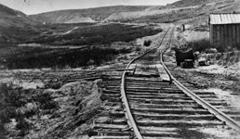
American Heritage Center, University of Wyoming
Railroad tracks
Born to a family of prominent farmers and manufacturers (Eli Whitney, inventor of the cotton gin, was a distant cousin), young Asa Whitney displayed ambition in business. In his teens he went to New York to work his way up the mercantile ladder. By the 1820s purchasing jobs sent him often to Europe, where in 1830 Whitney had the opportunity to ride an early British steamlocomotive. By middle age Whitney oversaw a successful import business. But a weakening economy shuttered its doors, and the financial impact cost him his home. When his second wife died during childbirth, Whitney decided to remove himself far away from the scenes of his misfortune. He opted for the other side of the world.
Eye-Opening Voyage
It took Whitney 153 days on a cramped sailing ship to reach China's Canton province. The kind-hearted merchant disliked the captain's treatment of his crew and the social inequality he encountered at colonial holdings along the way. He mused, "Oh how long must the mighty oppress & brutalize the weaker... When I see human beings in such oppressive ignorance & servitude, I cannot help but feel that they were created for a more noble & exalted purpose..." In China, Whitney did a brisk business over a year and a half. By 1844 when he began the voyage home, he'd secured for himself a comfortable fortune and the conviction that from then on, his duty would be to ennoble humankind.
A Corridor of Exchange
In the Pacific Railroad, Whitney found his purpose. Since 1830 pamphleteers had unsuccessfully championed its construction. The merchant now took up the cause. Whitney knew that linking coasts would unlock the commercial potential of China while eliminating infernal ocean commutes. He believed a railway would become the corridor of exchange between Europe and Asia, placing America at the center of the world's attention. Best of all, he saw vast opportunity for human improvement. "[It] would bring all our immensely wide-spread population together as one vast city; the moral and social effects of which must harmonize all together as one family, with but one interest -- the general good of all." An entire continent would open itself to be settled by the throngs of the East. And, he thought, the natives of those vast lands would join the American family.
Self-Financing Scheme
Whitney's optimism was overly idealistic but in accordance with his times. Manifest destiny, the idea that European Americans should and would expand the nation's boundaries, gripped the nation's imagination. The land-grabbing presidency of James K. Polk would soon increase territorial holdings to the Pacific. Groups of emigrants already moved west in search of fortune or homestead. And in 1845 Senator Zadock Pratt introduced the Memorial of Asa Whitney to legislators, calling for construction of a railroad west from Lake Michigan. Whitney foresaw a self-financing enterprise. He asked that government grant him 60-mile strips of land along the length of his route. Sale of this land to settlers would finance construction of the road. As settlement increased so would progress westward. For himself, Whitney asked only those lands left unsettled upon completion. Excess profits would maintain the road or finance public education.
Undeterred Optimism
In spite of Whitney's evangelism, Congress tabled the proposal. Undeterred, Whitney unleashed a publicity campaign that would last six years. He became an incredibly popular speaker and a darling of the newspapers. In Washington, however, other matters clouded progress. Territorial expansion led to bitter debates in the legislature over whether those lands would allow slavery. The issue was divided by sectional interests, and culminated in the tenuous Compromise of 1850. As years passed, and the country grew westward, those settlers Whitney hoped might fund his project instead ate up sections of his route. Alternate schemes were introduced, and opponents such as Thomas Hart Benton discredited Whitney's vision and the authenticity of his intentions. The merchant insisted, "I have but one motive, or object, and that is to see this great work successfully accomplished, which would be a sufficient reward for my labors."
Defeated
It was not to be. In 1851 Whitney's proposals were rejected one last time. Defeated, he faded into private life. He would live to see the completion of the transcontinental railroad accomplished by other men. Those speculators understood what he had not: that government support, business and spoils, not philanthropy, could build the railroad.
Ultimately, Whitney's major contribution was to make the road a popular topic of public debate. He caused it to take hold in the public mind, and there the idea resided even after his defeat. In 1869 he was largely forgotten, but Sacramento's May 8th jubilee, celebrating the railroad's completion, toasted his pioneering vision.

General Article: Native Americans and the Transcontinental Railroad
Other General Articles
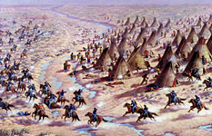
Colorado Historical Society
Plains Indians
As white explorers and settlers entered Western territory, they disrupted a centuries-old culture -- that of the Plains Indians. The arrival of the railroad and, with it, more permanent and numerous white settlement, spelled growing conflict between whites and natives. The troubles would erupt into an all-out war.
Massacre at Sand Creek
In autumn 1864, while the Civil War raged half a continent away, a group of Cheyenne Indians made winter quarters on Sand Creek in Colorado Territory, having been invited there by the U.S. Army. Forty miles away, at Fort Lyon, a regiment of cavalry mustered under Colonel John Chivington. Chafing for action, Chivington led his soldiers under cover of night to sleeping Sand Creek. At daybreak on November 29th, Chivington unleashed his men with the infamous order, "Kill and scalp all, big and little; nits make lice." The soldiers swept down upon the camp, surrounding unarmed natives and chasing away their ponies to prevent escape. Chief Black Kettle waved the white flag to no avail. Indiscriminate slaughter followed. Over 150 Cheyenne were murdered, most women and children. The rampaging soldiers mutilated their corpses, some removing genitals as prizes.
Retribution at Julesburg
Retribution fell 39 days later upon the frontier town of Julesburg, Colorado. An assembly of 1,000 Sioux, Arapaho, and Northern Cheyenne -- survivors of Sand Creek among them -- overran the town, killing civilians and soldiers and distributing their body parts across the countryside. They continued through Platte Valley, destroying stage stations and telegraph wires, effectively halting transcontinental communication. Later, the party returned to Julesburg and burned it to the ground.
Armed Response
General Grenville Dodge led the campaign against the northern Plains Indians following Julesburg, effectively dispersing war parties northward to the Powder River Valley. Dodge sent General Patrick Edward Connor after them with troops and scouts from one tribe friendly to whites, the Pawnees. Connor and his men missed the raiders but attacked a peaceful settlement of unsuspecting Arapaho on the Tongue River, killing almost 200.
The "Menace"
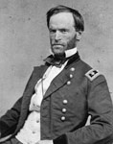
Denver Public Library, Western History Collection, F-44821
William Tecumseh Sherman
As the Union Pacific cut its way westward across the Platte Valley in 1865, its workers grew fearful of "the Indian menace." Certainly, the Northern Cheyenne, Sioux, and Arapaho maintained a presence on what had once been their prime hunting land. However, decades of mass immigration by settlers along the overland trails had already destroyed large swaths of the countryside for buffalo herds, forcing the tribes to disperse in search of food. Tribal leaders, wary of further conflicts with whites, usually ordered their warriors to stay away from the railroad, although young men could not always be controlled. Periodic sightings of Native Americans, skirmishes, and livestock raids persuaded chief engineer Dodge that the railroad needed serious protecting. He repeatedly requested troops of William Tecumseh Sherman. The latter declined, convinced that natives posed no real threat to the project.
Slaughter on the Bozeman Trail
An event in 1866 changed Sherman's attitude and put fear into the hearts of railroad workers, although it occurred away from their line. Plains Indians had watched as the Platte Valley turned into white America's highway. Now they were incensed by army fortification of the Bozeman trail through the Powder River Valley, their most sacred and fertile hunting ground. On December 21, decoys attacked a wood train outside Fort Philip Kearny. A garrison led by arrogant Captain William J. Fetterman, who had once boasted he could lick the entire Sioux tribe with just 80 men, rushed from the fort to support the wood-gathering party. As he left, a superior officer told Fetterman three times not to engage the Indians. He ignored orders. Indian decoys led their pursuers into a waiting mass of Cheyenne, Miniconjous, and Red Cloud's Oglala Sioux. Not a single soldier survived. "We must act with vindictive earnestness against the Sioux," Sherman seethed, "even to their extermination, men, women, children." For the immediate future, however, the army did nothing. Westward progress would suffice to force Native Americans from the Plains.
Incidents Along the Railroad
The railroad certainly received its share of harassment. Livestock was continuously rustled by tribal raiders, who also boldly shot up work crews and terrorized isolated station towns. Particularly vulnerable were route surveyors, who struck out on their own ahead of the work crews -- and sometimes paid for it with their lives. Twice, Native Americans sabotaged the iron rails themselves. In August 1867 a Cheyenne raiding party decided they would attempt to derail a train. They tied a stick across the rails and succeeded in overturning a handcar, killing its crew of repairmen, with the exception of a man named William Thompson. He was shot and scalped, but lived to tell about it as he traveled back to Omaha with his scalp in a pail of water by his side. In 1868 a group of Sioux created a more intense blockade, upturning both rails and piling wooden ties in between them, then tying the whole thing together with telegraph wire. The resulting wreck killed two crewmen, one of who was crushed beneath the train's boiler.
One Welcoming Tribe
Of all the Plains tribes, Pawnee Indians had the greatest presence on the line. Friendly to the American government and bitter enemies of the Sioux, the tribe welcomed the Union Pacific to their lands. The railroad offered Pawnee people free passage on its work trains, which the natives gladly accepted. In exchange, they staged mock raids and battles for visiting dignitaries at UP executive Thomas C. Durant's lavish 100th Meridian Excursion party. Under army Major Frank North, a uniformed battalion of 800 Pawnee men patrolled the railroad to protect crews and livestock from Sioux raiders. Their presence as a deterrent was quite effective. "I have never seen more obedient or better behaved troops," gushed one of North's superiors. "They have done most excellent service."
A Lost World
In 1876 the United States celebrated its might, gathered in part from the completion of the railroad, at the Centennial Exposition in Philadelphia. There on exhibit were the "very aristocracy of the Indian nation." The tribes who had roamed and hunted in the woods of the Northeast and the plains of the West found themselves a curiosity for the fair's visitors. The struggle was over, and Native American tribes had lost it, leaving the world of the West forever changed.

General Article: The Race to Utah
Other General Articles
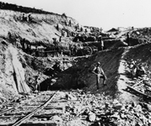
Utah State Historical Society
A worker pauses during construction
The Central Pacific and Union Pacific railroads vied to establish routes across the territory from western Iowa to northern California in a bitter contest. The Pacific Railroad acts of 1862 and 1864 granted land and government bonds to the companies on the basis of how many miles of track they laid, setting the stage for a wild seven-year race.
Hard Work, Big Rewards
While the Central Pacific labored eastward in the mountains of the Sierra Nevada, the Union Pacific built more rapidly westward across Nebraska and Wyoming. The Associates, as the Central Pacific directors called themselves, were steadfast in their aim -- they wanted their efforts to earn them more than mere existence as a Union Pacific feeder route through California. So they pushed their crews east, intent on grabbing as much land as possible. Mileage meant money, power, and a fantastic business opportunity. Whichever line-neared Salt Lake City, Utah first assured Mormon traffic on its route. That line that built through Utah's Weber Canyon, east of Ogden, possessed its coalmines -- a rich source of wealth and fuel. In April 1868, as the Central Pacific entered Nevada, UP executive Thomas C. Durant telegraphed CP head Leland Stanford to inform him that the Union Pacific had surmounted the Rockies. Stanford ironically replied, "May your descent be easy and rapid."
A Secret Deal
In September 1868, the Central Pacific learned that Union Pacific grading crews were almost through Echo Canyon, Utah, the last barrier before Weber. Soon the Union Pacific would lay its line in the coalfields. Moreover, the competitors now worked the same stretch of Utah desert, grading for two tracks where only one would ultimately be laid. On the 29th, Central Pacific crews passed a landmark that allowed CP executive Collis P. Huntington to unleash his strategy. Now within 300 miles of Monument Point, Huntington could legally petition Secretary of the Interior Orville Browning for an extension of the Central Pacific line to Echo Canyon -- over the Union Pacific's grade. Constant pressure on the secretary and misrepresentation of construction progress won Huntington his approval. Browning furthermore promised he would keep the decision secret. "By God, Charley, you must work as a man has never worked before," he wrote his associate, Charles Crocker. To Stanford he wired, "Go and see him!" It was a coded order to unleash men across 500 miles of desert to cover the proposed line.
An Embarrassed Retreat
Stanford, supervising in Utah in his typical uncommunicative fashion, did not think it prudent. So he did nothing. The Union Pacific was entrenched toward Echo Canyon, and advance Union Pacific crews now graded on the proposed line. "They are all over our line," he complained. "Often on or across." Huntington grew furious at Stanford, although the latter invited him to Utah to prove Weber had been lost. Huntington reset his sites on Ogden. On December 3, 1868, Browning informed the Union Pacific of his decision. UP chief engineer Grenville Dodge exploded. The Central Pacific had greatly exaggerated its progress, and was now "pretending to lay grade on the same or very nearly same grade that ours is now building upon." Dodge had friends from his army days, including Ulysses S. Grant, who would become president in January. The engineer unleashed a very public war upon Browning. Under increased scrutiny from press and peers, the secretary retreated from his earlier decision. He declared the government would go over both roads to determine an appropriate meeting point.
Fight to the Finish
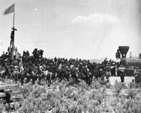
The Oakland Museum of California
A crowd gathers at Promontory Summit
Dodge's victory put the railroads in a new pickle. Shoddy construction work had been approved by both sides in the race to extend across Utah. And if the Central Pacific was cash-strapped, the Union Pacific was practically broke. Business practices of the latter had come under recent scrutiny from the press. Government examination threatened to ruin both enterprises. Suddenly it seemed advantageous for the railroads to reach an agreement themselves. On January 30, 1869, Congressman and UP ally Oakes Ames and Dodge met Huntington. They proposed convergence halfway between the completed tracks. Huntington replied, "I'll see you damned first." He was determined to attain more land. Plus, as Dodge soon learned, Huntington had secured bonds to Ogden before the close of the previous administration; the Central Pacific held ownership of that town. Dodge and Huntington met again on the evening of April 8, arguing through the night. They resumed in the morning and negotiated late into the evening. Huntington agreed to meet west of Ogden at Promontory Summit. Dodge conceded that the Union Pacific would turn over its road between Promontory and Ogden at full cost. The compromise upset Dodge's compatriots but was welcomed by Congress. Grateful to have the matter resolved, the legislature passed a special resolution approving the decision the next day. The railroads met at Promontory Summit on May 10, 1869.

General Article: Tunneling in the Sierra Nevada
Other General Articles
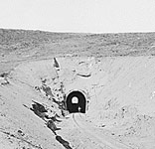
National Archives
One of the many tunnels in the Sierra Nevada
Builders of the transcontinental railroad faced geographical obstacles across the entire line. But none were quite as formidable as the snowy granite mountain range rising east of Sacramento. Getting through the Sierra Nevada would require fortitude, technology -- and the sacrifice of many workers' lives.
The Big Obstacle
In August 1865 early snows defeated the Central Pacific's initial attempt to begin work on Tunnel No. 6, the Summit Tunnel. The grand engineering feat of the Sierra Nevada would have to wait until the following year. Summer 1866 saw construction of the Grizzly Hill and Emigrant Gap Tunnels (Tunnels No. 1 and 2) west of Cisco. As fall approached, Chinese crews were taken off other parts of the line and hurried once more to the summit to get a jump on wintertime. Toil commenced on the Donner granite of Tunnel No. 6 in August 1866, with men blasting inward from what would become the east and west portals of the passage. Progress with black powder through hard rock was excruciatingly slow.
Four-Sided Approach
To speed progress, engineers decided to drill a vertical shaft midway along the projected tunnel line. Tunneling would take place on four faces at a time, as two teams worked inward from the eastern and western ends of the tunnel and two more teams worked back to back from the middle, moving outward. Workers began clearing the 8-by-12-foot shaft on August 27 and made good progress for the first 30 days, at which point the job of hoisting rubble from the shaft via hand derrick became too hard.
New Use for an Old Engine
Engineers found a solution in the abandoned Sacramento, the locomotive that had taken the first pioneering ride on Theodore Judah's Sacramento Valley Railroad. Stripped of all non-essential parts, it was driven to Gold Run, at that point the end of the Central Pacific tracks. Its wheels were removed and its body transferred to a logging truck driven by ten yoke of oxen. In a dangerous and treacherous effort, the freight team hauled what remained of the Sacramento -- a 12-ton steam engine -- to the top of Donner Pass, where it was let down carefully above Tunnel No. 6 and housed in the large wooden enclosure now surrounding the sunken shaft. The whole process took six weeks.
Massive Work Force
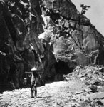
Library of Congress
A chinese worker hauls equipment
With the shaft completed, two teams of Chinese workers descended to the middle of the rock and began blasting the tunnel from the inside out. The steam engine was employed to cart out their debris. On September 1, work finished on the Emigrant Gap Tunnel (Tunnel No. 2), and those crews were redistributed to the winter quarters and tunnel work waiting upon the summit. That winter the men at Tunnel No. 6 were almost completely Chinese, with a few Caucasians on the west end. Gangs consisted of one white foreman per 30 or 40 workers, with each gang working one of three rotating eight-hour shifts a day. An average of six to 10,000 men worked on the railroad that winter, with as many as 12,000 at one time.
Terrible Snows
A fierce winter in 1866-1867 brought 44 separate storms. The snow pack averaged 18 feet at the summit. "No one can face these storms when they are in earnest," Engineer John Gilliss recalled. The heaviest of them began on February 18, 1867 and continued until February 22, when harsh winds kept powder astir in the air until the snow started again days later. The storm continued unabated until March 2. Drifts clogged the entrance to every tunnel, turning many workers into full-time shovelers. CP crews worked, ate, and slept in this inhospitable environment, creating a network of tunnels under the snow to link their campsites with the work sites. The bad weather held up provisions, diverted workers from railroad building to snow-management, and created a volatile, freezing world of additional dangers.
Risks to Workers
The railroad lost uncounted men to snow. Avalanches could cut down dozens at a time. "There was one large snow slide at Strong's Canyon known as Camp 4. In this camp were two gangs of Chinese for Tunnels 11 and 12, also a gang of culvert men. The slide took it all, and one of the culvert men was not found until the following spring," wrote Gilliss. Even when the tunnels were done, maintaining them was a monumental task. In the spring of 1868 most of the high-altitude tunnels were completely blocked by ice, which had to be blasted loose and shoveled out. And when snow wasn't killing men, the work was.
"Nitroglycerin Tells"
In total, the Central Pacific engaged 11 tunnel projects (Nos. 3 through 13) in the Sierra that winter. Seven of them clustered in a two-mile stretch east of Donner Summit. Black powder was expensive, and its preparation labor-intensive, requiring men to drill deep two-inch-wide holes by hand in order to clear shallow amounts of rock. But progress increased substantially on all fronts when British chemist James Howden appeared in February 1867. He brought nitroglycerin, which he mixed on location. The compound allowed for shallower holes of narrow width, but its blasts achieved a much greater destructive yield. Nitroglycerin debris was also much easier to move than the debris of black powder, saving a lot of cumulative time and sweat. Workers were able to advance up to two feet per day on all four faces, instead of measuring each hard-won inch.
A Staggering Feat
With its rapidly accelerated pace, the Central Pacific continued work on the Summit Tunnel into the spring and summer of 1867. Workers broke through in August, just one year after the vertical shaft had been drilled. Tunnel No. 6 was a truly staggering feat of engineering. It measured 1,659 feet in length, and reached, at its deepest, 124 feet into the rock. It sat more than 7,000 feet above sea level. Calculations used to position its end points and the central shaft were so accurate that the workers found they were only two inches off when they broke through. And it had been hand-carved, without electricity and without steam-powered tools, except for the single old engine used to hoist debris. The Union Pacific ramped up their track-laying speed and built confidently into Nevada, knowing their hardest task was behind them.

General Article: The Credit Mobilier Scandal
Other General Articles
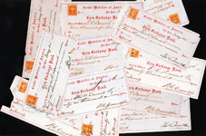
The Levi Leonard Papers, The University of Iowa Libraries, Iowa City, Iowa
Durant created Credit Mobilier to financially benefit from the railroad's construction
For Union Pacific executive Thomas Durant, it was a money-making machine. It was a revolutionary business model previously unknown on American soil. It was secretive and utterly opaque to the reporters who eventually tried to discover its workings. And it wasn't illegal at the time -- though it should have been. Durant chartered a company named Credit Mobilier of America to garner profits from railroad construction, guaranteeing he and other insiders would realize a fortune from the railroad without exposing themselves to the project's high-stake risks.
Structuring a Scam
Durant was convinced building a railroad would be more profitable than running one. He had to get into the construction business. With partners, he purchased an idle fiscal agency and altered its structure to mirror a French concern (hence the name). In simple terms, the new company welcomed a select group of investors while limiting their liability. Prior to Credit Mobilier, corporate law held investors liable for their entire personal holdings. In contrast, Credit Mobilier investors were only responsible for the extent of their investment. Durant paid crony Herbert M. Hoxie to submit a construction bid to the Union Pacific. No one else got the call to bid, and as the only bid received, Hoxie's offer was unanimously approved. Hoxie signed the contract over to his benefactor -- and Durant transferred it into the name of Credit Mobilier.
All the Pay, None of the Risk
In essence, Durant hired himself to construct the railroad, paying Credit Mobilier with money given to the Union Pacific by government bonds and risk-taking investors. He subcontracted railroad work to real construction crews while using inflated estimates to ensure significant profit. Because there was no liability, it didn't matter whether the railroad actually got built. In case of forfeiture, Durant could not lose the profit he had already earned. With a crazily bent, ox-bow-shaped line out of Omaha adding nine unnecessary profit-generating miles to construction, the money-making machine got off to a roaring start.
Power Struggle
Three years later, conflict in the Credit Mobilier boardroom brought construction to a standstill. Investor Oliver Ames leapt over Durant to assume the Union Pacific's presidency; furious, Durant filed an injunction forbidding Credit Mobilier from assigning new construction contracts to replace the expiring Hoxie agreement. Oliver and his Congressman brother Oakes Ames managed to oust Durant from the Credit Mobilier board, which then split into two factions. More injunctions followed, as did months of bitter impasse. Exasperated crews waited for work at the end of the tracks. The Ames brothers eventually set them working without a contract, which meant each completed mile equaled unrealized profit. That resolved the issue, if not tensions. In October 1867, Oliver and Oakes Ames grudgingly reinstated Durant; he in turn endorsed an Ames construction contract that sent money from those miles flowing retroactively into their pockets.
"We Should Not Be Interfered With"
On the strength of renewed profits and a declared dividend, Credit Mobilier boomed. Congressman Oakes Ames, representing company interests on Capitol Hill, soon found himself overwhelmed with legislators demanding a piece of the action. He distributed stock to two senators and nine representatives in 1867. Some eventually returned the gift. Ames recorded his transactions in a ledger. For discretion's sake, he often kept the stock in his name and dispensed earnings where necessary. By virtue of their posts, all the recipients held influence over railroad legislation, but none seemed to sense any conflict of interest in their purchases. And Ames was intent on gaining their support. "We want more friends in this Congress," Ames wrote, "and if a man will look into the law (and it is difficult to get them to do it unless they have an interest to do so), he can not help being convinced that we should not be interfered with."
Scandal erupted in election season 1872, as president and UP friend Ulysses S. Grant came up for his second term. Testimony from a lawsuit against the Credit Mobilier contained a partial list of Oakes Ames's stock contacts of half a decade earlier. Mistaken for a listing of stock recipients, the itemized names included incumbent Vice President Schuyler Colfax, Vice Presidential nominee Henry Wilson, Speaker of the House James G. Blaine, and ten others (among them future president James Garfield). The anti-Grant press seized upon the revelation as "the most damaging exhibition of official and private villainy and corruption ever laid bare to the gaze of the world." A blizzard of controversy overwhelmed the public -- but had little ultimate effect upon the elections.
"Whitewash!"
Speaker Blaine, who had turned down Credit Mobilier stock and nonetheless seen his name dragged through the mud, moved that Congress investigate the charges. Called before a Capitol Hill committee, Oakes Ames insisted that nothing illegal had transpired. He was therefore willing to talk. His colleagues turned on Ames, who in turn produced the ledger book. It cleared Blaine and Wilson, but incriminated Colfax and 13 other legislators. With a rapt public and incendiary press following its every move, the Committee decided not to take measures against those Ames fingered, choosing only to punish Ames himself and James Brooks -- the sole Democrat -- with congressional censure. No criminal or civil charges were filed against any of the Credit Mobilier's scoundrels. "Whitewash!" blared the press. The Capitol seemed darkened by shame.
No Happy Ending
In January 1869 young muckraker Charles Francis Adams Jr., brother of journalist and historian Henry Adams (and descendant of two Adams presidents), wrote of the scheme's complexity. "What this Credit Mobilier is seems to be as much shrouded in mystery as is the fate of the missing $180,000,000 of capital stock of these roads," he complained. He also pointed out that the financial improprieties would result in higher taxes on the trade carried by the railroad in the future, meaning that, as Durant had planned, someone else would foot the bill for cleaning up a villainous mess. As a crowning insult to the public trust, the schemers were never punished.
For more on the Credit Mobilier and its relevance to business scandals today, read New Yorker financial columnist James Surowiecki's essay, "Durant's Big Scam."

General Article: The Credit Mobilier Scandal
Other General Articles
The Levi Leonard Papers, The University of Iowa Libraries, Iowa City, Iowa
Durant created Credit Mobilier to financially benefit from the railroad's construction
For Union Pacific executive Thomas Durant, it was a money-making machine. It was a revolutionary business model previously unknown on American soil. It was secretive and utterly opaque to the reporters who eventually tried to discover its workings. And it wasn't illegal at the time -- though it should have been. Durant chartered a company named Credit Mobilier of America to garner profits from railroad construction, guaranteeing he and other insiders would realize a fortune from the railroad without exposing themselves to the project's high-stake risks.
Structuring a Scam
Durant was convinced building a railroad would be more profitable than running one. He had to get into the construction business. With partners, he purchased an idle fiscal agency and altered its structure to mirror a French concern (hence the name). In simple terms, the new company welcomed a select group of investors while limiting their liability. Prior to Credit Mobilier, corporate law held investors liable for their entire personal holdings. In contrast, Credit Mobilier investors were only responsible for the extent of their investment. Durant paid crony Herbert M. Hoxie to submit a construction bid to the Union Pacific. No one else got the call to bid, and as the only bid received, Hoxie's offer was unanimously approved. Hoxie signed the contract over to his benefactor -- and Durant transferred it into the name of Credit Mobilier.
All the Pay, None of the Risk
In essence, Durant hired himself to construct the railroad, paying Credit Mobilier with money given to the Union Pacific by government bonds and risk-taking investors. He subcontracted railroad work to real construction crews while using inflated estimates to ensure significant profit. Because there was no liability, it didn't matter whether the railroad actually got built. In case of forfeiture, Durant could not lose the profit he had already earned. With a crazily bent, ox-bow-shaped line out of Omaha adding nine unnecessary profit-generating miles to construction, the money-making machine got off to a roaring start.
Power Struggle
Three years later, conflict in the Credit Mobilier boardroom brought construction to a standstill. Investor Oliver Ames leapt over Durant to assume the Union Pacific's presidency; furious, Durant filed an injunction forbidding Credit Mobilier from assigning new construction contracts to replace the expiring Hoxie agreement. Oliver and his Congressman brother Oakes Ames managed to oust Durant from the Credit Mobilier board, which then split into two factions. More injunctions followed, as did months of bitter impasse. Exasperated crews waited for work at the end of the tracks. The Ames brothers eventually set them working without a contract, which meant each completed mile equaled unrealized profit. That resolved the issue, if not tensions. In October 1867, Oliver and Oakes Ames grudgingly reinstated Durant; he in turn endorsed an Ames construction contract that sent money from those miles flowing retroactively into their pockets.
"We Should Not Be Interfered With"
On the strength of renewed profits and a declared dividend, Credit Mobilier boomed. Congressman Oakes Ames, representing company interests on Capitol Hill, soon found himself overwhelmed with legislators demanding a piece of the action. He distributed stock to two senators and nine representatives in 1867. Some eventually returned the gift. Ames recorded his transactions in a ledger. For discretion's sake, he often kept the stock in his name and dispensed earnings where necessary. By virtue of their posts, all the recipients held influence over railroad legislation, but none seemed to sense any conflict of interest in their purchases. And Ames was intent on gaining their support. "We want more friends in this Congress," Ames wrote, "and if a man will look into the law (and it is difficult to get them to do it unless they have an interest to do so), he can not help being convinced that we should not be interfered with."
Scandal erupted in election season 1872, as president and UP friend Ulysses S. Grant came up for his second term. Testimony from a lawsuit against the Credit Mobilier contained a partial list of Oakes Ames's stock contacts of half a decade earlier. Mistaken for a listing of stock recipients, the itemized names included incumbent Vice President Schuyler Colfax, Vice Presidential nominee Henry Wilson, Speaker of the House James G. Blaine, and ten others (among them future president James Garfield). The anti-Grant press seized upon the revelation as "the most damaging exhibition of official and private villainy and corruption ever laid bare to the gaze of the world." A blizzard of controversy overwhelmed the public -- but had little ultimate effect upon the elections.
"Whitewash!"
Speaker Blaine, who had turned down Credit Mobilier stock and nonetheless seen his name dragged through the mud, moved that Congress investigate the charges. Called before a Capitol Hill committee, Oakes Ames insisted that nothing illegal had transpired. He was therefore willing to talk. His colleagues turned on Ames, who in turn produced the ledger book. It cleared Blaine and Wilson, but incriminated Colfax and 13 other legislators. With a rapt public and incendiary press following its every move, the Committee decided not to take measures against those Ames fingered, choosing only to punish Ames himself and James Brooks -- the sole Democrat -- with congressional censure. No criminal or civil charges were filed against any of the Credit Mobilier's scoundrels. "Whitewash!" blared the press. The Capitol seemed darkened by shame.
No Happy Ending
In January 1869 young muckraker Charles Francis Adams Jr., brother of journalist and historian Henry Adams (and descendant of two Adams presidents), wrote of the scheme's complexity. "What this Credit Mobilier is seems to be as much shrouded in mystery as is the fate of the missing $180,000,000 of capital stock of these roads," he complained. He also pointed out that the financial improprieties would result in higher taxes on the trade carried by the railroad in the future, meaning that, as Durant had planned, someone else would foot the bill for cleaning up a villainous mess. As a crowning insult to the public trust, the schemers were never punished.

General Article: Nitroglycerin
Other General Articles
Nitroglycerin is an explosive compound formed by the combination of glycerol and nitric and sulfuric acids. It was first synthesized in 1864 by chemist Ascanio Sobrero, who destroyed his notes for fear of the damage his highly unstable discovery might cause. But word got out, and the volatile compound came into use even before 1867, when Alfred Nobel combined nitroglycerin with an absorbent clay to create dynamite, which substantially reduced the dangers of the compound in its purest form.
A Leaking Crate
In 1866, one year before Nobel's discovery, San Francisco had its formal introduction to nitroglycerin. On April 14, freight steamers out of Panama landed a cargo of unmarked crates from Hamburg, three of which were taken by train to the Central Pacific at Dutch Flat. All but one of the rest shipped to local construction suppliers. On April 16 CP builders Charles Crocker and James Harvey Strobridge conducted their first tests of nitroglycerin on the hard rock of the Sierra Nevada, where workers were making excruciatingly slow progress with hand tools and black powder. In San Francisco, a wharf employee noticed that the remaining Hamburg crate was leaking some kind of oil. The offensive package was forwarded to the Wells Fargo office, located downtown at the corner of California and Montgomery streets. After lunch, a group of Wells Fargo employees decided to pry open the box and see what was inside.
Deadly Explosion
The resulting explosion leveled the Wells Fargo office and all surrounding buildings, including the nearby Union Club, which was still serving lunchtime crowds. Fifteen people died, many more were seriously wounded, and strewn among the rubble was the torn evidence of human remains. As San Francisco worked itself into a panic over the unknown, deadly substance, a nitroglycerin sample detonated prematurely on the Central Pacific line, ripping apart six workers. It did not take long for press and public to put two and two together. The railroad came under heavy criticism. It had not been their shipment that detonated but, as reasoning went, it easily might have been -- and had Central Pacific crates exploded in transit, the human casualties would have been greater than what Wells Fargo had seen.
Making It to Order
It mattered not to Charles Crocker, who had witnessed nitroglycerin in action. The trouble was getting his hands on more of the stuff. The state had confiscated all private holdings of nitroglycerin following the explosion at Wells Fargo and banned its transportation within California. Then, in early 1867, as Central Pacific workers seemed hopelessly mired in the Summit Tunnel, a British chemist named James Howden walked unannounced into E. B. Crocker's Sacramento office. He declared that he could manufacture nitroglycerin on-site in the mountains, thus allowing the railroad to circumvent the transportation ban. All he needed was the lordly amount of $300 per month and a steady supply of ingredients. Tracking down pure glycerol would be tricky, but the Crockers agreed to give it a try.
Faster, Easier, Better
Howden's recipe practically burned through rock. Nitroglycerin required shallower holes, and fewer of them. Its smoke cleared faster than that of black powder, its debris cleaned up more easily, and it worked in wet rock, where powder did not. Most importantly, it allowed the crews substantial progress. Engineer John Gilliss recalled, "In the headings of the Summit Tunnel the average daily progress with powder was 1.18 feet per day; with nitroglycerin, 1.82 feet, or over 54 percent additional progress. In the bottom of the Summit Tunnel, average daily progress with powder, full gangs, was 2.51 feet; with nitroglycerin, 4.38, or over 74 percent in favor of nitroglycerine." Or, as E. B. Crocker put it, "Nitroglycerine tells."
Unknown Number of Deaths
Gilliss would remember only two accidents with nitroglycerin, and he claimed those would have occurred even if the victims had been using black powder. Another engineer recalled differently, stating that because of their careless use of the unstable compound "many an honest John went to China feet first." However many lives it claimed, once fresh air blew the length of the Summit Tunnel, Charles Crocker decided he'd had enough of nitroglycerin. He terminated use of the dangerous compound along the Central Pacific route.
At the turn of 1869 (when it finally encountered some rock), the Union Pacific, following the example of its competitor, used nitroglycerin to bore through Utah's Echo and Weber Canyons.

General Article: The Impact of the Transcontinental Railroad
Other General Articles
On May 10, 1869, as the last spike was driven in the Utah desert, the blows were heard across the country. Telegraph wires wrapped around spike and sledgehammer transmitted the impact instantaneously east and west. In San Francisco and New York, wires had been connected to cannons facing outward across the ocean. When the signal from the spike came through, the cannons fired. The world was put on notice: the transcontinental railroad was completed and America was moving to the forefront of the world's stage.
The World Grew Smaller
One day later, the first transcontinental freight train rumbled out of California on its way to the east coast. It carried in its hold an emissary of the Asian markets: a shipment of Japanese teas. On May 15, though the road required hundreds of thousands of dollars in patchwork along its length, regular passenger service opened for business. Travelers could make the trip between San Francisco and New York in a week. No longer did passengers or cargo have to take the treacherous route across ocean and Panama that had killed railroad advocate Theodore Judah. The coasts were connected -- and the world as Americans knew it had grown smaller.
A Competing Canal
Railroad pioneer Asa Whitney had once dreamed an iron route would re-center the world toward America, making it a conduit of exchange between Asia and Europe. In this sense, his vision of the grand project remained unfulfilled. Just six months after the meeting at Promontory Summit, workers half the world away consummated their own monumental feat of engineering. Opened in November, 1869, Egypt's Suez Canal linked Asia and India to Europe by a single waterway, thus ensuring that exchange between the two regions would continue to circumvent American soil.
Surging Interstate Trade
However, the transformation achieved in intercontinental trade was substantial. Within ten years of its completion, the railroad shipped $50 million worth of freight coast to coast every year. Just as it opened the markets of the west coast and Asia to the east, it brought products of eastern industry to the growing populace beyond the Mississippi. The railroad ensured a production boom, as industry mined the vast resources of the middle and western continent for use in production. The railroad was America's first technology corridor.
Improved Public Discourse
As it encouraged the growth of American business, so too did it promote evolution of the nation's public discourse and intellectual life. Americans could travel across the length of the continent in a matter of days, and gaze upon their country in its entirety from the windows of their train cars. Conversations begun in the east ended in the west. Books written in San Francisco found homes on New York shelves just one week after their publication. The rails carried more than goods; they provided a conduit for ideas, a pathway for discourse. With the completion of its great railroad, America gave birth to a transcontinental culture. And the route further engendered another profound change in the American mind. Here was manifest destiny wrought in iron; here were two coasts united; here was an interior open to settlement. Distances shrank, but identification to land and fellow American grew in inverse proportion.
A Disaster for Native Americans
Not everyone would benefit from that transformation. The transcontinental railroad was not the beginning of white settlers' battles with Native Americans. Nor was it the final nail in the coffin. But it was an irrevocable marker of encroaching white society, that unstoppable force which would force Indians onto reservations within decades. By 1890, even the Powder River Valley -- the rich hunting ground so hard won by Red Cloud and the Oglala Sioux -- would be lost. New treaties scattered the Indians to reservations and opened the last great Native American holding to the settlers so steadily branching outward from the iron road. And the buffalo herds upon which Indians depended had been nearly depleted. They were easy prey to sport-hunters brought to the plains by the carload. More disastrously, the railroad introduced the herds to American industrial production, for which they became one more resource to be mined en masse. Millions of buffalo fell to indiscriminate slaughter, their hides shipped back along the rails to the markets of the East.
A Web of Rails
The transcontinental railroad did not long remain the sole venue of travel through America's center. Lines spider webbed outward from its branch points, conveying north and south the settlers coming west to consume millions of acres of land. By 1900 a number of routes ran parallel -- the Northern Pacific and Southern Pacific among them -- reaching westward from Mississippi to the Pacific just like the pioneering road.

Track Layout Geometry
Here are some more advanced ideas for LEGO train layouts, while still keeping consistent with the restrictions of track geometry. While none of these ideas are original to myself (with the possible exception of the yard at the bottom), I hope this explanation will inform and inspire you to build better and hassle-free LEGO layouts.
New as of Jan 7 2008: this page is now available in Italian courtesy of ITLUG, the Italian LEGO® Users Group. You can see the Italian translation on the ITLUG Web site. (EDIT 9/15/2008: updated URL)
Note: This page was originally written several years before LEGO switched from powered 9V track to all-plastic track with battery trains. If you are using the all-plastic track you can ignore considerations of short circuits (see the Wye oh Wye? section). Also, the Flex Track piece is not included in this discussion; that makes some track shapes easier to achieve, though trains are more likely to derail on Flex Track than normal track that is assembled according to the principles on this page. The all-plastic Double Crossover track is also not included.

Table of Contents
- Introduction
- Crossovers
- Changing Two Curves To a Straight
- Wye oh Wye?
- 22½° Diagonal Track
- 45° Diagonal Track
- Diagonal Track with Switches
- The Big Yard
- Track Designer files

Introduction
LEGO track geometry is very limiting. There are only a handful of available pieces. From left to right, these are: straight, curve, left switch (or point), right switch, and cross track (There is also the newer Flex Track piece, but it is not covered by this document):
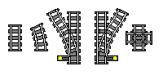
Each straight track piece is 16 studs long and 8 wide. The curved pieces produce a 22½° bend, so that 4 of them make a 90° turn. The switches have a different kind of curve in them, and they are meant to be used in conjunction with a curved track to produce parallel tracks. Here are some of the basic track concepts that are valid with LEGO track. Each one preserves perfect alignment with the studs on the large grey baseplate (48×48 studs).
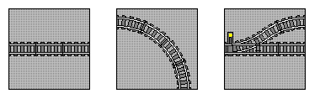
Straight track can go anywhere. But in order for the alignment of tracks to be maintained consistently through curves and switches, it is necessary to adopt some standards. The standard that works best is:
- Adjacent parallel tracks have a pitch of multiples of 16 studs; or put another way, 8 studs between tracks.
This is dictated by the geometry of the LEGO track switch, which creates parallel tracks of this pitch.
- On a 48×48 baseplate, tracks may run down the center of the baseplate or 4 studs in from either edge. This is for symmetry and in order to preserve the previous rule.
- On a 32×32 baseplate, tracks may only run 4 studs in from either edge.
- Horizontal and vertical track segments must begin and end on a baseplate boundary, except for dead-end spurs.
If you follow these rules, you will never have trouble getting your layout to line up.
On first glance you may think this is too limiting, because the following restrictions would seem to be implied by the above rules:
- All curves must be 90°, consisting of 4 curve pieces.
- All switches must have a curve piece on the “spur” end to make the track parallel to the “main” line.
However, there are some additional things you can do with LEGO track geometry that do not violate our rules. This is because in the real world, there is a little bit of slack in the connections, and the studs can still be made to line up with certain alternate configurations.
[top]

Crossovers
A crossover is where you have two parallel tracks with a line connecting them. The standard way is to take the switch geometry described above, and create a crossover where the two switches line up with a pair of curved tracks in between. But look at the right hand crossover: it also lines up, only instead of the two curves there is a single straight piece:
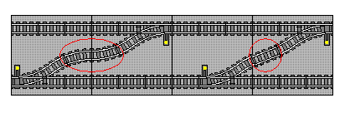
How does this work? Well, it turns out that 2 curved track pieces, when positioned at 22½° from horizontal, have the same amount of vertical distance between start and end as a single straight at that angle. Also, the horizontal distance is almost exactly double that of a straight.
But what if you put nothing in between? Then the tracks don’t line up right:
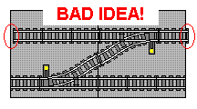
DON’T DO THIS. The areas circled in red are not lined up properly. If you want these tracks to line up elsewhere on your layout you will run into problems. Just add a straight or two curves (or two curves and several straights, to make a parallel track in between). Remember, a switch is NOT the same as a curve!
[top]

Changing Two Curves To a Straight
It’s not just crossovers that let you replace two curves with a straight. Here are some other situations where this trick can help avoid unnecessary zigzagging of your trains.
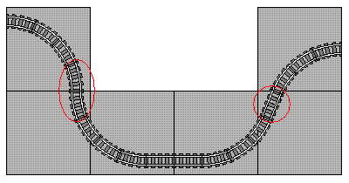  A standard "S" curve (left) is made with eight curves. But replace the two middle curves with a straight (right) for a smoother shape that uses less space. | 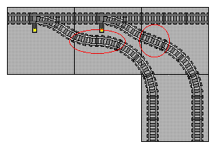  A branch line coming off a switch can be given a gentler curve, and take up less real estate, with the same technique.
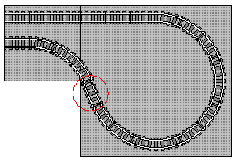
You can loop back on yourself by replacing 2 curves with a straight.
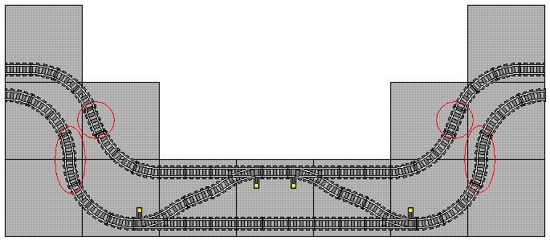
A crossover requires extra space between the parallel tracks. Here’s one way, using both types of "S" curves,
to separate them enough for a crossover without interfering with spacing on the rest of the main line.
[top]

Wye oh Wye?
A wye (named for the letter Y) is one of the most common ways for trains to turn around, and it allows you to connect the loops of your layout in different ways for interesting variations.
Caution: a wye made of powered LEGO (or any DC model train) track will have a short circuit! You will need to electrically isolate the track segments in at least one spot in order to make it work. You can do this by inserting paper between the track pieces before connecting them, and then cutting away the excess. Of course, if you are using plastic track that consideration does not apply.
The wye on the left uses standard LEGO geometry, with 4 curved tracks in each 90° turn. In the one on the right, the double curves (3 sets of them) are replaced by straights. This shrinks the size and produces more reasonable curves.
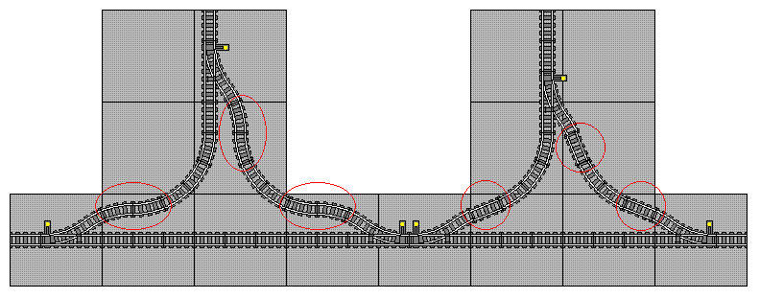
[top]

22½° Diagonal Track
Another convenient coincidence that comes in handy when designing layouts involves a straight track running at a 22½° angle. If you use 12 straight tracks with a curve at either end, you can still line up your track at both ends while having a more unusual track angle.
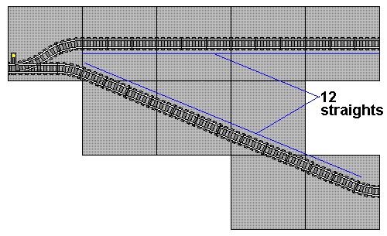
This works because of the magic of Pythagorean triples. Like the well-known 3-4-5 triangle, you can make a perfect right triangle using dimensions of 5, 12, and 13. In such a case, the angle is 22.62°, which is close enough to 22½ that it works. Thanks to Jason Railton for pointing this out. But why is it 12, and not 13, you ask? Remember above where you can replace 2 curves with a straight? The 13th straight is replaced by the curves at either end of the 12. Note that a horizontal track of 12 units will line up nicely with the end of the diagonal track.
This trick only works if the begin and end of the turn are parallel. If you want to have the begin and end be perpendicular, you need an extra straight. Here’s why:
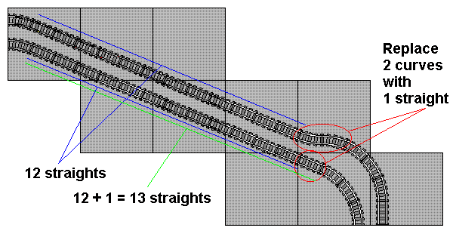
[top]

45° Diagonal Track
There are no Pythagorean triples that produce anything close enough to a 45° angle, but we can use math to derive a result anyway. Trigonometry tells us that the distance traveled horizontally or vertically for each unit of diagonal movement is the sine of 45° (or cosine if you prefer; they’re equal for a 45° angle), or 0.7071. This is also half of the square root of 2 (1.4142). So we need a number that, when multiplied by 0.7071, produces something close enough to an integer that it will work with LEGO track.
1 x 0.7071 = 0.7071  2 x 0.7071 = 1.4142  3 x 0.7071 = 2.1213  4 x 0.7071 = 2.8284  5 x 0.7071 = 3.5355  6 x 0.7071 = 4.2426  7 x 0.7071 = 4.9497  8 x 0.7071 = 5.6568  9 x 0.7071 = 6.3639  10 x 0.7071 = 7.0710 GOOD  11 x 0.7071 = 7.7781  12 x 0.7071 = 8.4852  13 x 0.7071 = 9.1923  14 x 0.7071 = 9.8994  15 x 0.7071 = 10.6065  16 x 0.7071 = 11.3136  17 x 0.7071 = 12.0207 BETTER  18 x 0.7071 = 12.7278  19 x 0.7071 = 13.4349  20 x 0.7071 = 14.1420  The best choice is 17 straights, but you should be able make 10 work also. | 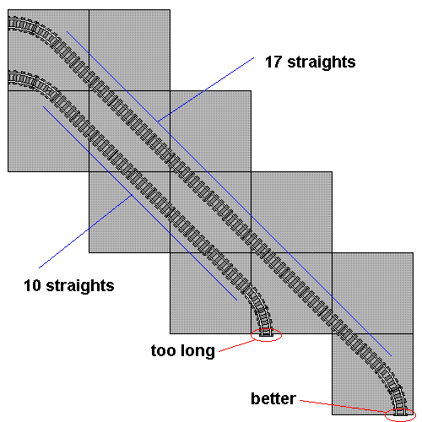
Thanks to Larry Pieniazek, David Koudys, and Jeff Van Winden for their postings in a thread about this topic on LUGNET.
Note: this requires that the beginning and end be perpendicular to line up properly. If you need the beginning and end to be parallel, add a right angle turn (four curves) to the above. You can simplify it by replacing two of the curves with a straight, but you will still need to go the “wrong way” with one curve track in order for it to line up:
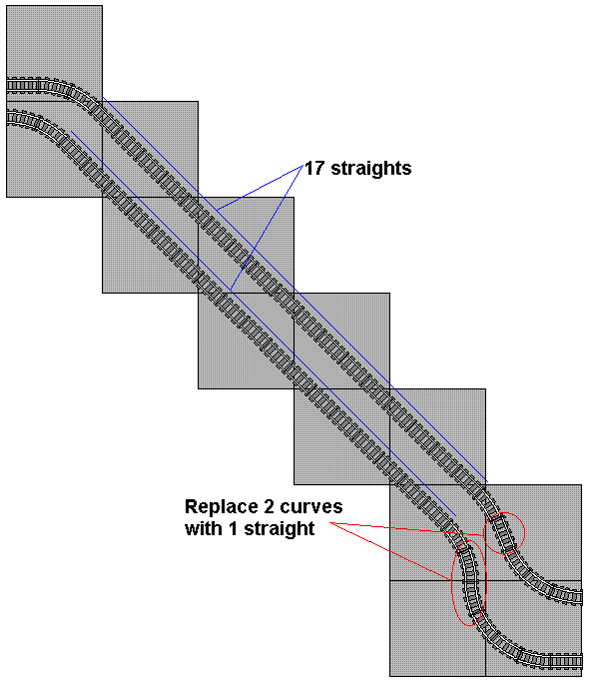
[top]

Diagonal Track with Switches
You can add a switch and curve to each end, or replace the two resulting curves with a straight, just like we did in the earlier crossover:
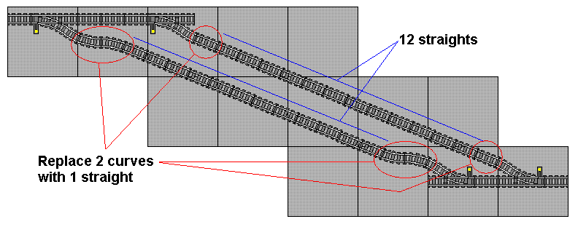
The result is a pair of switches separated by 14 straights. Put several of these together, and you have a switching yard:
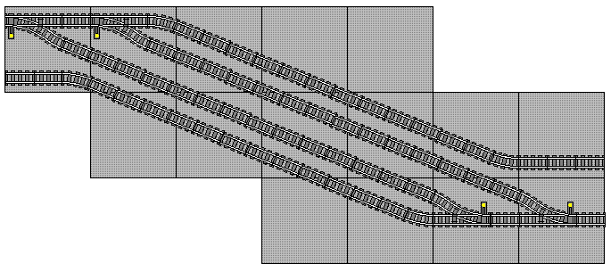
We can also do the same thing with a 45° track:
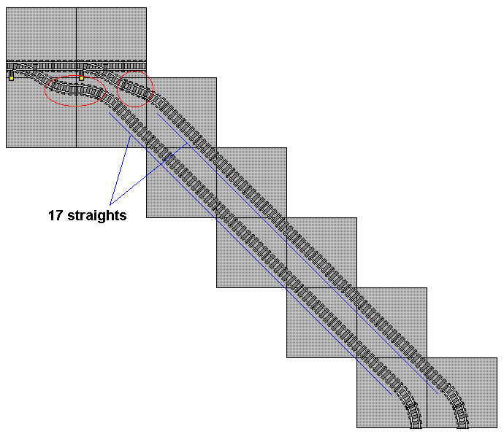
[top]

The Big Yard
Here is a big switching yard that uses several of the ideas shown here:
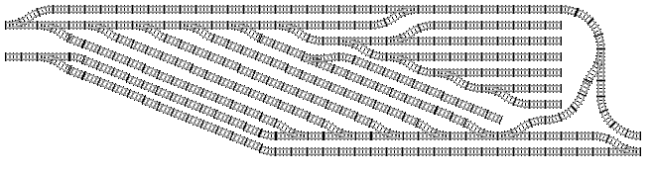
You can also find more ideas by Tim Strutt at his Brickshelf folder.
[top]

Track Designer files
If you have the Track Designer program on your PC, here are the files for each of these examples (minus the text and arrows and such):
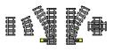
LEGO Track Parts
Alignment Examples
Crossovers
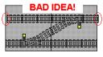
Bad Crossover
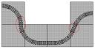
"S" Curves
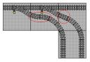
Spur Line Curve
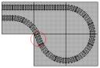
Loopback
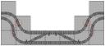
Making Room for Crossover
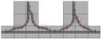
Wyes
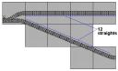
22½° Diagonal
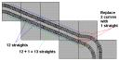
22½° Diagonal with Turn
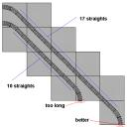
45° Diagonal
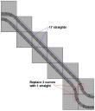
45° Diagonal without Turn
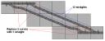
22½° Diagonal with Switch
22½° Diagonal Simple Yard
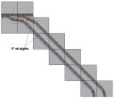
45° Diagonal with Switch
Big Yard

